First Baptist Church of Brooklyn

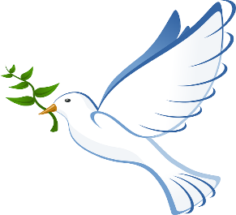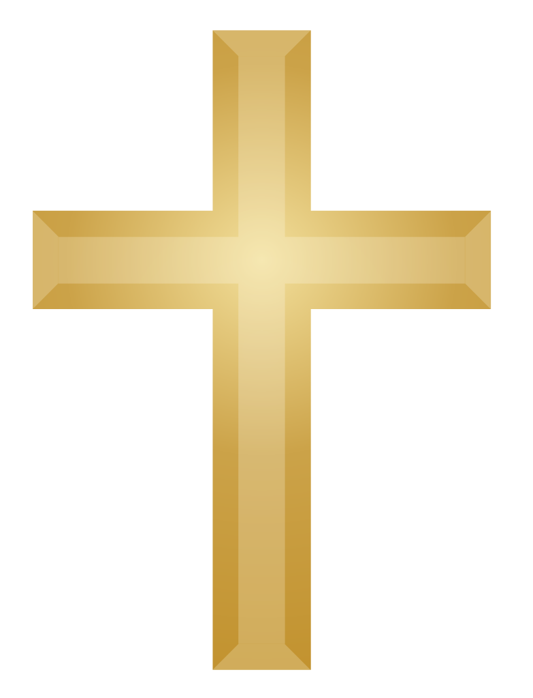

BMS

[This Photo](http://www.freeimageslive.co.uk/free_stock_image/cross-dove-jpg) by Unknown Author is licensd under [CC BY](https://creativecommons.org/licenses/by/3.0/)

* Old Timey title
* Navigation on right
* Main color green, darker for breaks, lighter for text, and white.
* Pictures of churc for header.
* Easy to use for both phone and website.
* Don’t look so simply, make it eye candy.
* Add missions, events, staff with pics of staff, giving, calendar, google maps location on home, about us, media, etc…
* Get different symbols from people and find which one church likes best before using
* W3schools.com
* The dove is holy spirit.
* Cross is Jesus
* The rectangle is the church, which is behind God. This symbolizes that we are always with God and find him first before all.
* We can do a picture as a background. Just have very bright font over it if it is a dark picture.
* Find Icons on

